LINK Video KPL

<https://telkomuniversityofficial-my.sharepoint.com/:f:/g/personal/iqbalfatur_365_telkomuniversity_ac_id/EgsAfZaVUyNLuW77iQpmA84BtLlGvoDgfKg901b041_s_A?e=kMjkaH>

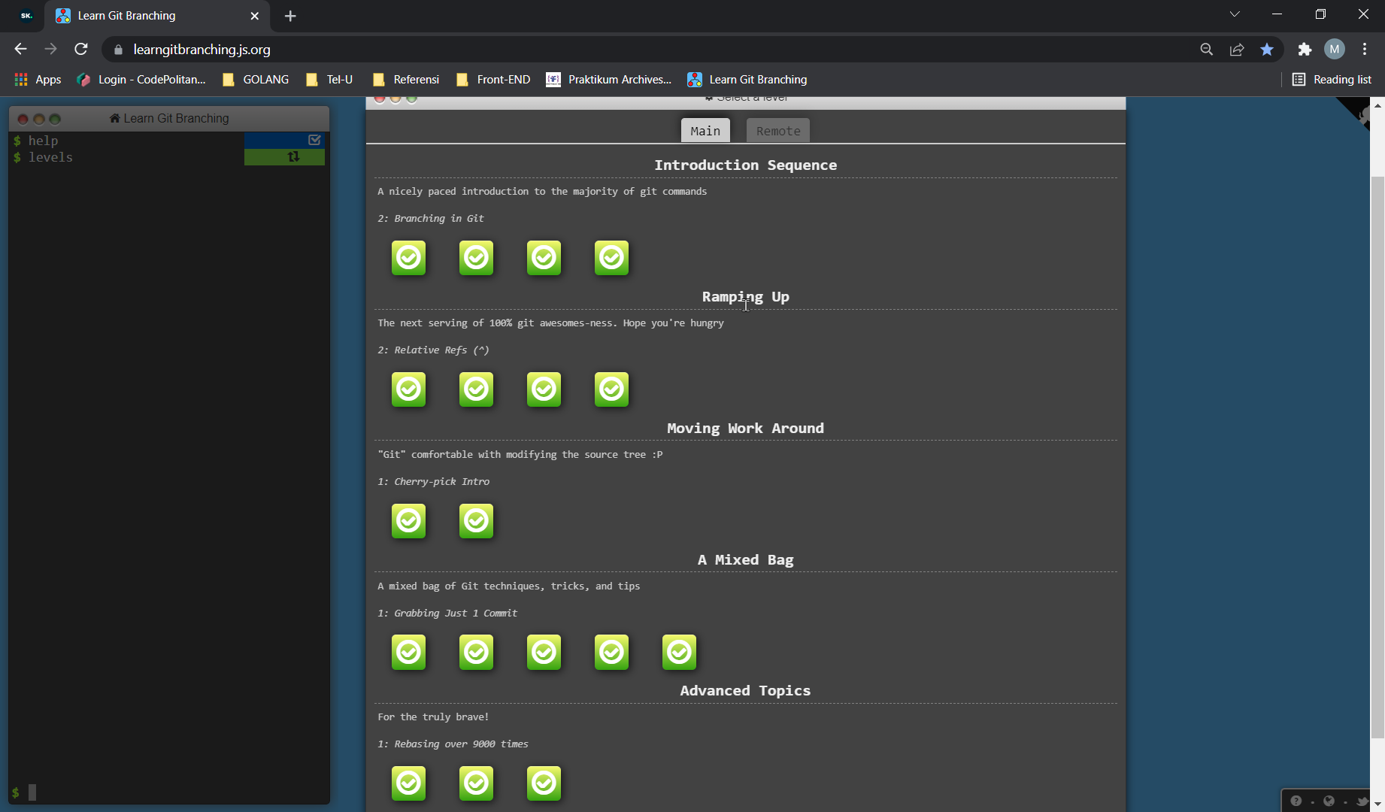Screenshot

